LAB 4
Part 1
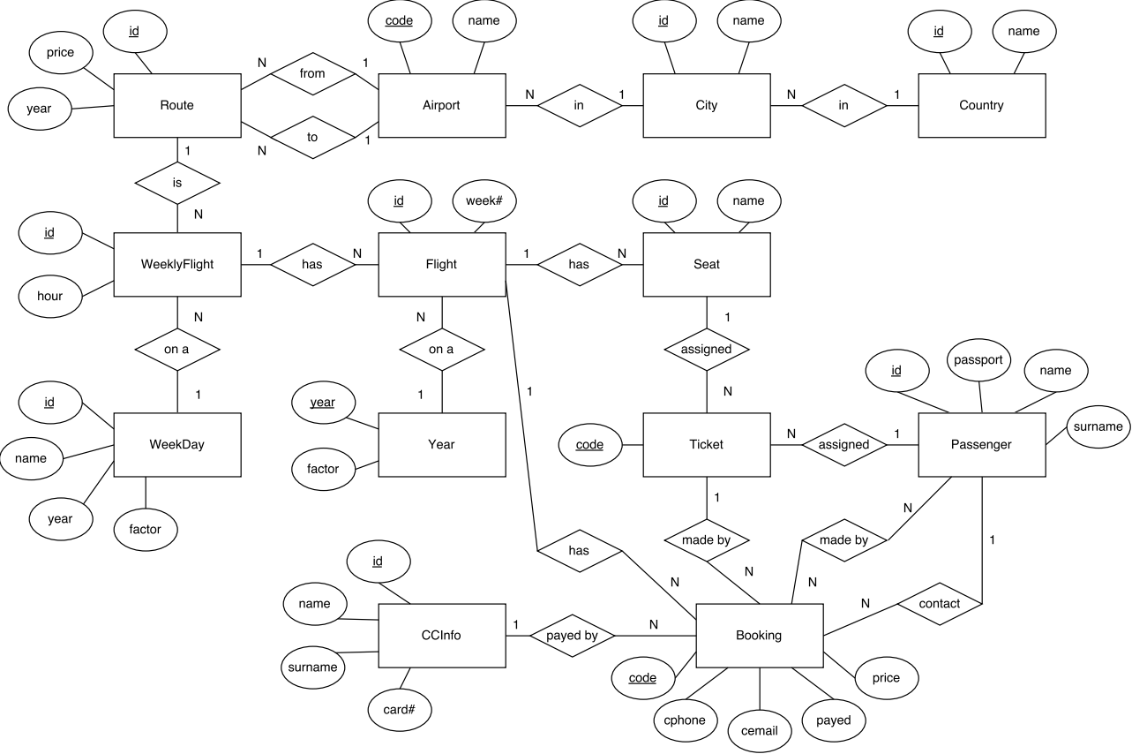
id
to
from
Route
code
name
city
Airport
id
name
country
City
id
name
Country
id
weekday
route
Weekly Flight
hour
id
wf
Flight
week#
id
name
flight
Seat
code
seat
passenger
Ticket
booking
code
contact
cphone
Booking
cemail
payed
price
payedby
flight
id
name
Passenger
surname
passenger
booking
Passenger Bookings
id
card#
name
CCInfo
surname
id
name
Week day
year
factor
year
year
factor
Year
price
year
passport
Normalization

Route:
id -> to, from, year (not 3rd nf)
to, from, year -> price
Airport:
code -> name, city
City:
id -> name, country
Country:
id -> name
Weekly Flight:
id -> weekday, route, hour
Week Day:
id -> name, year
name, year -> weekpfactor
Flight:
id -> weeklyFlight, week#, year

Year:
year -> yearpfactor
Seat:
id -> name, flight
Ticket:
code -> seat, passenger, booking
Passenger:
id -> passport
passport -> name, surname
Booking:
code -> contact, payed, price, payedby, flight
contact -> cphone, cemail
Passenger Bookings:
passenger, bookings
CCinfo:
id -> card#, name, surname
card# -> name, surname

